Elastic Load Balancer – Stickiness

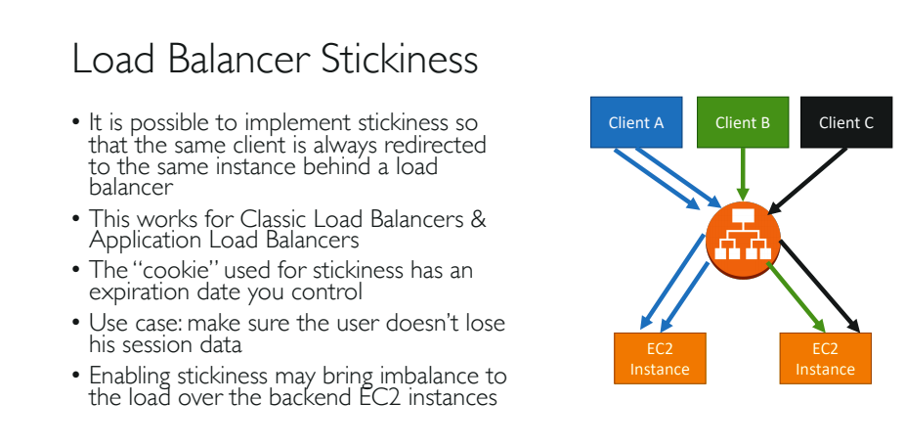

To set the stickiness in Application Load Balancer, follow the diagram:

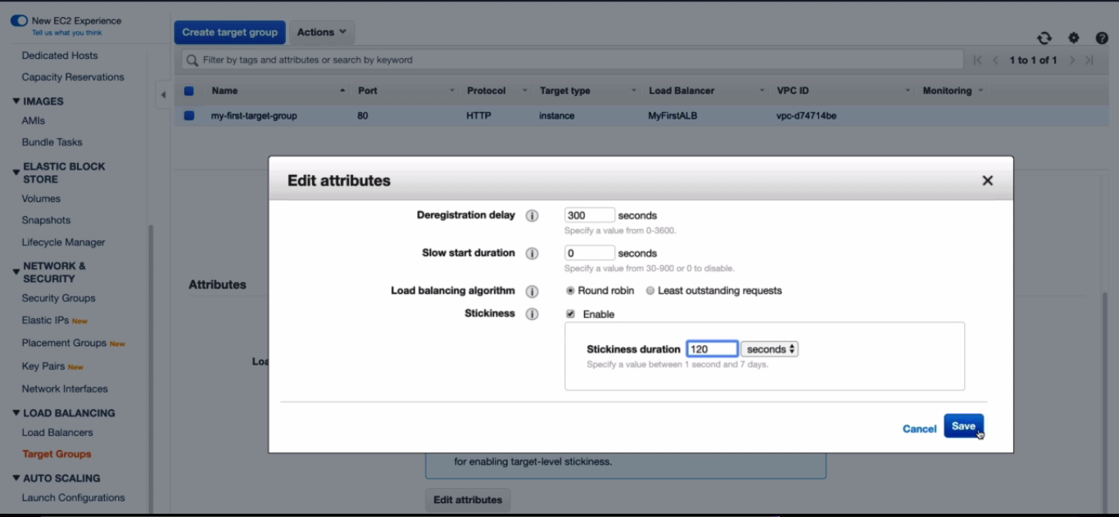

Now go to DSN url and copy paste on the browser.

If you refresh the page, the ip address will not change, because it sticks to one single instance for 120 seconds, according to the above image.